Name _______________________
Geography of Latin America Project
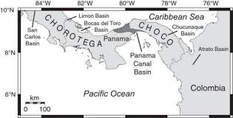
The Isthmus of Panama known as the "Crossroads of the Americas" connects North and South America. It came under Spanish influence during the 1530s.
It has nearly 2, 5000 miles of total coastline along the Caribbean Sea to the north and Pacific Ocean to the south. Mountain ranges divide the land into wetter rain forests on the Caribbeaen side and drier grasslands on the Pacific side. The indigenous meaning of the country's name, "abundance of fish," reflects Panama's reputation as a paradise for water sports enthusiasts and eco-tourists alike.
- Read and analyze the poem, “Old Panama.”
- Research a different place: The Panama Canal, the windward islands, OR Patagonia.
- Use that research to create a poem that describes the place you chose using at least 2 poetic techniques and write a brief explanation.
You will find information on discoveryeducationcom. Your password is huron. Find chapter 3.1 in the World Geography & Cultures course, Chapter 3.1 Geography of Latin America, Elaborate Activity #3: You as Artist. Click on that to view this assignment.
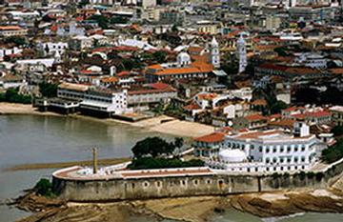
Old Panama
1
By Randolph Atkin

A ruined old church tower, standing lonely by the sea,
And grey walls in the jungle, peeping out mysteriously;
A little, old, weed-covered bridge, fast falling to decay;
Dim traces of a highway where the green-backed lizards play,
And over all the tropic breeze, which, straying to and fro,
Tells the story of the glory of those days of long ago.
How often, in the years gone by, I’ve lingered by that shore,
And fancied I was living in those stirring days of yore;
The same old stars their loving beams down through the night did shower,
The same old moon rose slowly up behind the crumbling tower;
The Southern Cross, symbolic like, hung in th sky above,
And at my feet the lapping waves were crooning songs of love.
Again the Spanish galleons at their anchors gently sway,
As treasure-laden mules start out across the Isthmian way…

In the graphic organizer below, take notes on the content of the poem.
Based on the poem and information on Discovery, what is the geography of Panama like?

What images does the poet use to make Panama feel real to you?

Based on the context of the poem and a dictionary, define each word.
peeping=_______________stirring=______________
Yore=___________crooning=________________ galleons=______________

Poets use figurative language and other literary techniques to emphasize the meaning of their poems. “Old Panama” contains several of these elements. Among these are:
- Imagery, words that create a metal picture of a place (a ruined old church)
- Personification, in which an animal, object, or other nonhuman thing is made to seem like a person in some way (the wind sang)
- Sensory language, words that appeal to the senses and make you see, hear, feel, taste, and smell the things the poet is describing

Identify the elements of poetry in “Old Panama” placing them in the table below.
Poetic techniques
Evidence of this technique in the poem

Imagery-using words to create a mental picture

Personification-giving human qualities to an animal, object, or non-human thing

Sensory language-using words that appeal to one of the five senses

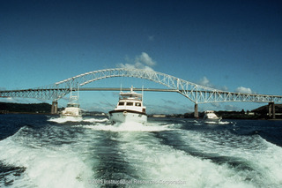
Research the Panama Canal, Windward Islands, OR Patagonia
2
After you choose one of the three above, explore the video and reading resources provided by Discovery Education. While you read and watch, fill out the notes organizer on the next page.
For Panama: in the search bar upper right search “The Panama Canal”
- Choose The Panama Canal Reading Passage…1914
- Go the previous page and watch the video segment “The Panama Canal” (3:44)
For Windward Islands : in the search bar upper right search “The Windward Islands”
- Choose the first reading passage
- Choose The Northern Windward Islands of the Lesser… (4:49)

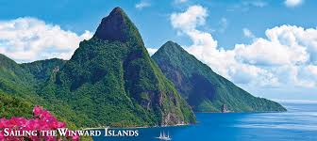

For Patagonia: in the search bar upper right search “Patagonia”
- Choose “Reading Passage-Patagonia”
- Watch any of the videos
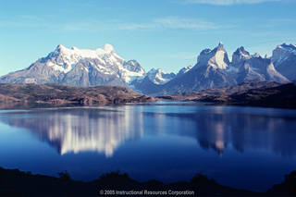
Question
Response

What are the physical characteristics of the place? What would the location look like, feel like, or sound like?

What are the human characteristics of the place? What do people do for a living? How does the geography influence the way people live?

3
Write your own 14 line poem about the location you chose using 2 poetic techniques.
Some poetic techniques you might use are: Alliteration (silly Suzie), Personification (the wind sang), Simile (she is like an angel), Metaphor (she is an angel), Sensory Imagery that appeals to the senses (feel, see, touch, hear, taste) or rhyme.
4
After you complete your poem, write a paragraph explaining your work.
What title would you give a poem about this region? Why?

